**Test a Perceptual Phenomenon**

**Q.1. What is our independent variable? What is our dependent variable?**

**Ans**: Independent: The fact that the font colour and the word name is same or not.

Dependent: The time taken by a person to name the colour written.

**Q.2. What is an appropriate set of hypotheses for this task? What kind of statistical test do you expect to perform? Justify your choices.**

**Ans:**

Ho - **Null Hypothesis:** There is **no** significant difference in the population average response time in viewing the congruent words vs viewing the incongruent words. There would be a lower mean time for the incongruent tests than the congruent tests. (μC ≥ μI)

Ha - **Alternative Hypothesis**: There is a significant difference, positive or negative, in the population average response times. (μC < μI)

The recommended statistical test we should use for this, is a T-test as this we don’t know the mean of the total population however we have detailed data on a sampled group for both the congruent and incongruent tests.

**Q.3. Report some descriptive statistics regarding this dataset. Include at least one measure of central tendency and at least one measure of variability.**

**Ans:**

Congruent: Mean- 14.05; SD- 3.56

Incongruent: Mean- 22.02; SD- 4.8

**Q.4.**  **Provide one or two visualizations that show the distribution of the sample data. Write one or two sentences noting what you observe about the plot or plots.**

**Ans:**

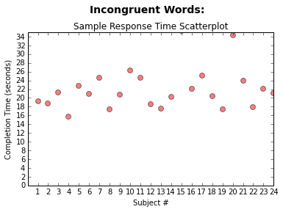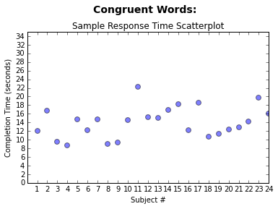

The congruent words sample has a distribution between 8 and 22 seconds and has a lower average completion time compared to the incongruent words scatterplot which shows the distribution is between 15 to about 26 seconds with what appears to be one outlier at 35 seconds. The average completion time is definitely higher.

**Q.5. Now, perform the statistical test and report your results. What is your confidence level and your critical statistic value? Do you reject the null hypothesis or fail to reject it? Come to a conclusion in terms of the experiment task. Did the results match up with your expectations?**

**Ans:**

µD: -7.9648

S: 4.86482691

df: 23

t-stat: -8.020706944

at α 0.05, t-critical: -2.06865761; 2.06865761

P: 4.103E-08

95% CI: (-25.3527231, 9.42314)

* Null Hypothesis will be rejected. At α 0.05, the time to name colours is significantly different between congruent and incongruent tasks. People do not name colours at the same speed when the word’s meaning and its colour match, as when they do not match. The result confirms my expectations.

**Q.6. What do you think is responsible for the effects observed? Can you think of an alternative or similar task that would result in a similar effect? Some research about the problem will be helpful for thinking about these two questions!**

**Ans:**

* The brain is responsible.
* Another similar task that could result in a similar result is the idea that is mentioned by Raymond De Young and Associate Professor of Environmental Psychology and Planning at the University of Michigan, School of Natural resources and Environment that states, “Most humans are so proficient at reading, at perceiving whole words, that they do not easily notice the individual letters. This is why proofreading is so hard to do. This tendency to quickly perceive words is used in testing for the Stroop effect”. The task of proofreading is similar task as the tests we did as it presents a similar Stroop Effect.*

* <http://www.snre.umich.edu/eplab/demos/st0/stroopdesc.html>

** <http://stattrek.com/probability-distributions/t-distribution.aspx>

*** <https://en.wikipedia.org/wiki/Numerical_Stroop_effect>